## **Deliverable2. Final Project Report**

***Objective***

* Objective of your Project.
* At the beginning of the project, I wanted to make a menu driven program that may be used by restaurants. I was able to achieve a working reservation list that restaurants may use when people call to make a reservation. You can use it to create a reservation for a lunch or dinner. Also you may add, delete, and even find a reservation for a specific date and time.

***Design***

* Menu options are the following: Add, Delete, Find, Quit, Lunch, and Dinner
* Classes are ReservationBook, Reservation, Lunch, and Dinner. In that order.
* Some variables I used are Int, String, and double.

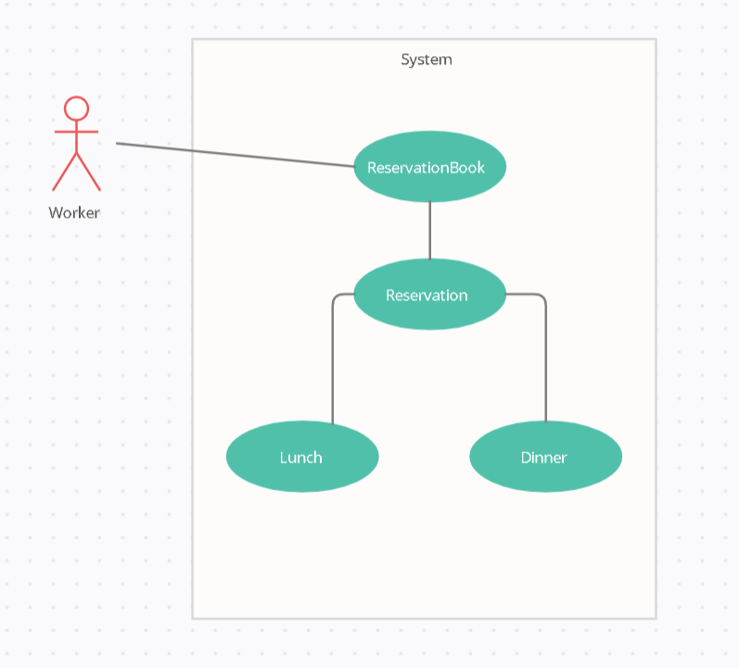

***Output***

* Honestly, I expected to program something really simple, at first I just had three classes but ended with four and very pleased with the outcome.
* Input would be information about the person making a reservation and the date and time, output data would be similar.
* 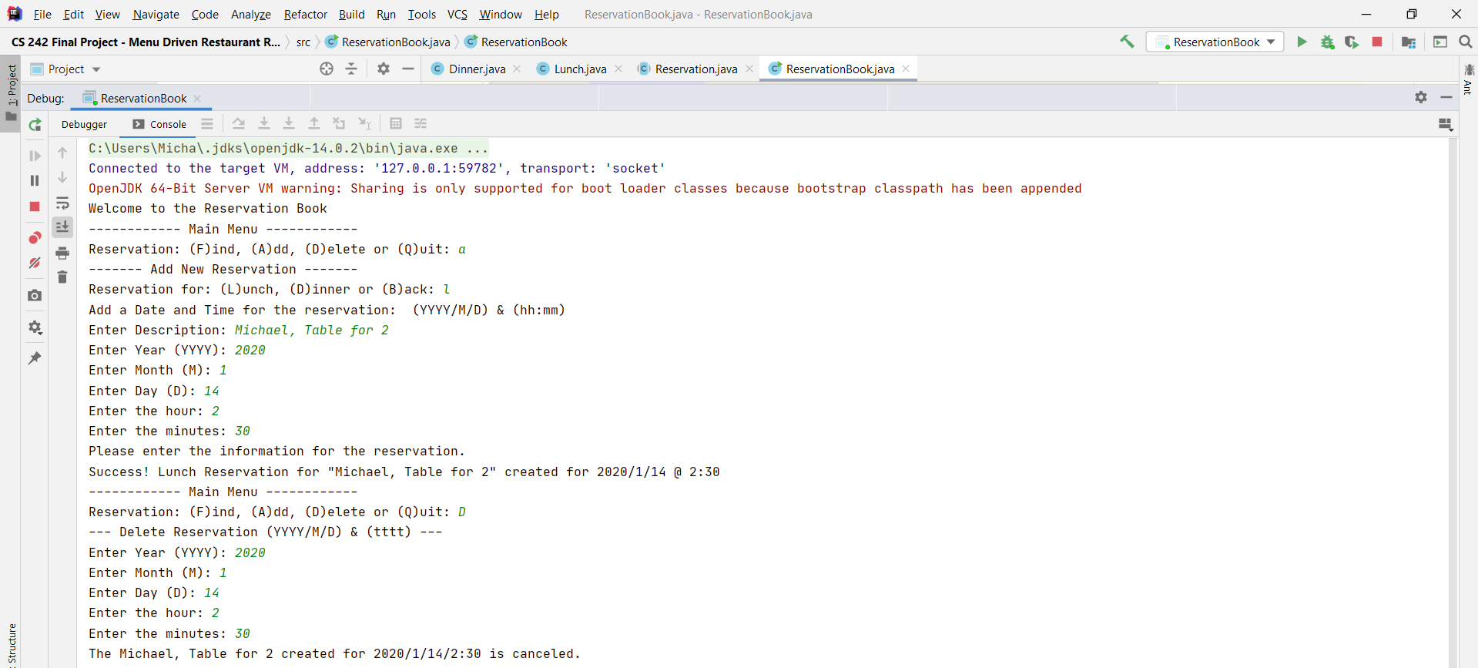
* In the sample I proved of my code running, I used add and delete to show a reservation being added and being deleted.

***Challenges***

* 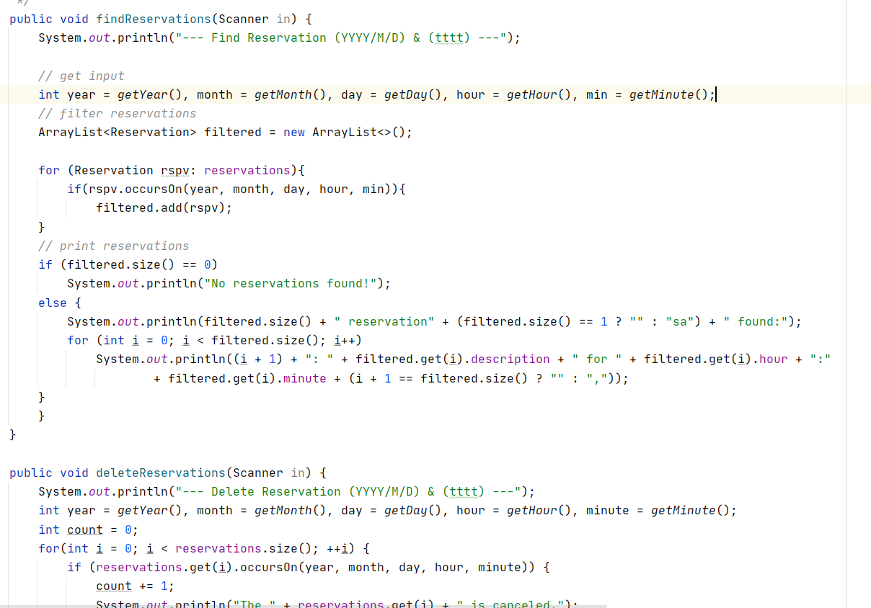
* This was the most difficult part of my code. Getting the findReservation and deleteReservation to work properly. I had to constantly test and fix the program. I referred back to other programs we’ve made during the semester and the notes I had took to be able to get the code to work. The problem was using the wrong function and what I was calling.
* So how my program works is that once you run the program. It will ask what you would like to do. Find, Add, Delete, or Quit.
* Find is to find a reservation already made,
* Add is to add a new reservation
* Delete is to remove a reservation already made
* Quit it to cancel the program.
* My moments of “enlightenment” did happen as in what else I could do with this. And in the end its definitely something I would like to experiment until next semester.

***References***

Programming Projects 1, 2, 3, 4, 5 done throughout the semester.

Lab 1-8 done throughout the semester.

Pogil Activities

Websites I used:  
<https://stackoverflow.com/questions/30355302/incompatible-types-required-int-found-java-lang-string-basic-programming>

For an error I was getting.

<https://stackoverflow.com/questions/29789057/class-must-either-be-declared-abstract-or-implement-abstract-method-error/29789387>

Another type of error I was getting.